ENUM4LINUX-NG TOOL – COMPREHENSIVE TECHNICAL DOCUMENTATION
An Advanced SMB & Windows Enumeration Tool for Ethical Hacking & Penetration Testing

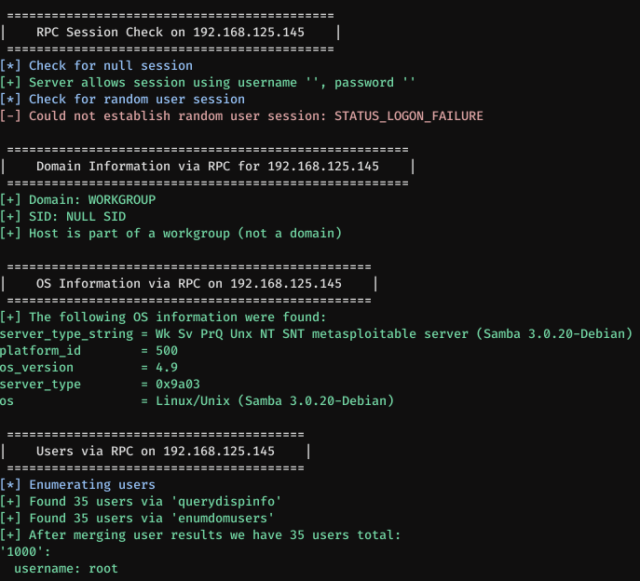
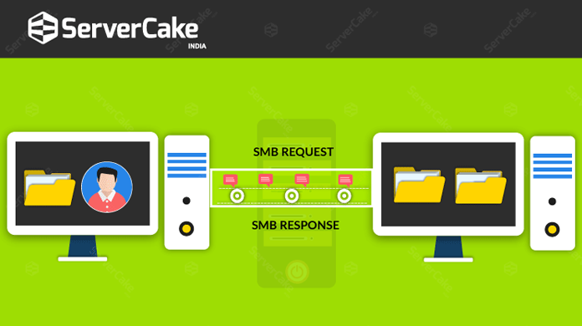

ABSTRACT
Windows-based environments and SMB (Server Message Block) services are common targets in penetration testing due to frequent misconfigurations and legacy compatibility requirements. Proper enumeration of SMB services is essential before attempting authentication attacks, privilege escalation, or lateral movement. This document presents a comprehensive technical study of Enum4linux-ng, a modern rewrite of the classic enum4linux tool. The report explains the theoretical background of SMB enumeration, the internal working mechanism of enum4linux-ng, command usage, practical case studies, advantages, limitations, and defensive considerations. The objective of this documentation is to provide an academic and practical understanding of enum4linux-ng suitable for cybersecurity coursework, lab records, interviews, and professional penetration testing engagements.

1. INTRODUCTION
In Windows networks, SMB is used for file sharing, printer access, authentication, and inter-process communication. Because SMB often exposes information even without authentication, it becomes a prime target during the Enumeration phase of penetration testing.
Attackers frequently exploit weak SMB configurations to discover:
- User accounts
- Shared folders
- Domain information
- Password policies
Enum4linux-ng automates these enumeration techniques and provides structured, readable output that significantly improves efficiency over manual SMB querying.

2. OBJECTIVE OF THE STUDY
The objectives of this documentation are:
- To understand SMB and Windows enumeration techniques
- To study the working mechanism of enum4linux-ng
- To analyze enum4linux-ng command usage and options
- To demonstrate real-world usage through practical case studies
- To evaluate strengths, limitations, and security implications
- To provide exam-ready and submission-ready content

3. BACKGROUND: SMB ENUMERATION IN CYBER SECURITY
SMB enumeration is part of the Scanning & Enumeration phase in penetration testing. It focuses on identifying:
- SMB shares and permissions
- Local and domain users
- Groups and roles
- Password policies
- Operating system and domain details
SMB services often allow limited information disclosure even without valid credentials, especially in misconfigured or legacy environments.
Enum4linux-ng builds on this concept by combining multiple SMB enumeration techniques into a single automated workflow.

4. OVERVIEW OF ENUM4LINUX-NG TOOL
Enum4linux-ng is an open-source SMB enumeration tool written in Python, designed as a modern replacement for the original enum4linux. It leverages tools such as smbclient, rpcclient, and crackmapexec-style techniques to enumerate Windows systems effectively.
Key improvements over the original enum4linux include:
- Cleaner and structured output
- Better error handling
- Modular execution
- Support for both anonymous and authenticated enumeration
Enum4linux-ng does not exploit vulnerabilities directly; it focuses strictly on information disclosure and enumeration.

5. ARCHITECTURE AND WORKING MECHANISM

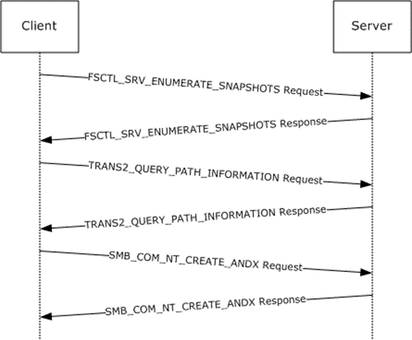
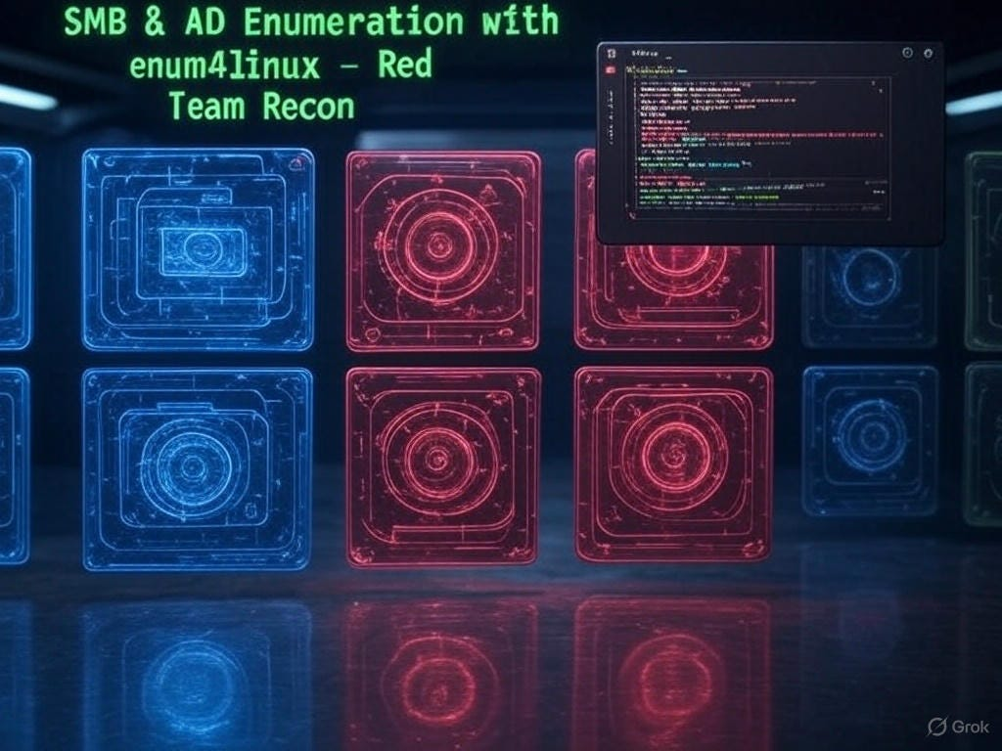
Enum4linux-ng follows a modular enumeration workflow:
- Target Identification
The target IP address or hostname is provided.
- SMB Service Detection
The tool checks for open SMB ports (139, 445).
- Authentication Handling
Anonymous or provided credentials are used.
- Enumeration Modules Execution
Modules query users, shares, groups, and policies.
- Result Correlation & Output
Information is aggregated and presented in a readable format.
This modular design allows controlled and efficient enumeration.

6. INSTALLATION AND ENVIRONMENT
Enum4linux-ng is pre-installed in Kali Linux.
To verify installation:
enum4linux-ng --help
Enum4linux-ng requires network connectivity to the target and works best in internal network assessments.

7. COMMAND USAGE AND ANALYSIS
7.1 Basic Enumeration (Anonymous)
enum4linux-ng 192.168.1.10
Performs SMB enumeration using null sessions where allowed.

7.2 Verbose Output
enum4linux-ng -v 192.168.1.10
Provides detailed execution logs and findings.

7.3 Specify Username and Password
enum4linux-ng -u user -p password 192.168.1.10
Used when valid credentials are available.

7.4 Specify Domain
enum4linux-ng -u user -p password -d DOMAIN 192.168.1.10

7.5 Save Output to File
enum4linux-ng 192.168.1.10 -o enum4linux_results.txt

8. PRACTICAL CASE STUDY
Scenario
A penetration tester assesses an internal Windows server during an enterprise network test.
Execution
enum4linux-ng 192.168.146.128
Observations
- Enumerated domain name and SID
- Discovered multiple user accounts
- Identified readable SMB shares
- Extracted password policy details
Impact Analysis
The enumerated information enabled targeted password attacks and privilege escalation planning.

9. ADVANTAGES OF ENUM4LINUX-NG
- Modern and actively maintained
- Cleaner output compared to enum4linux
- Supports authenticated and unauthenticated enumeration
- Excellent for Windows and Active Directory environments
- Beginner-friendly yet powerful

10. LIMITATIONS OF ENUM4LINUX-NG
- Limited to SMB-based services
- Effectiveness depends on SMB configuration
- Requires network access to target
- Less useful against hardened environments

11. ENUM4LINUX-NG VS SIMILAR TOOLS
Tool | Focus Area | Strength
Enum4linux-ng | SMB enumeration | Structured output
enum4linux | Legacy SMB enum | Basic
CrackMapExec | Post-exploitation | Automation
smbclient | Manual SMB access | Control
Enum4linux-ng is best suited for initial Windows enumeration.

12. SECURITY AND DEFENSIVE CONSIDERATIONS
Organizations can defend against enum4linux-ng enumeration by:
- Disabling anonymous SMB access
- Enforcing SMB signing
- Restricting share permissions
- Monitoring SMB enumeration attempts

13. LEGAL AND ETHICAL CONSIDERATIONS
Enum4linux-ng must only be used on systems where explicit authorization has been granted. Unauthorized SMB enumeration may violate corporate policies and cyber laws.

14. CONCLUSION
Enum4linux-ng is a powerful and efficient tool for enumerating Windows and SMB environments. Its ability to extract valuable information without exploitation highlights the importance of secure SMB configuration. Mastery of enum4linux-ng equips cybersecurity students and professionals with essential skills for Windows network reconnaissance and penetration testing.

15. REFERENCES
- Kali Linux Documentation
- Microsoft SMB Protocol Documentation
- OWASP Windows Security Testing Guide

